**Name :** Yadav Vishal Tahsildar

**Roll No :** 69

**Class :** TEIT2

**Batch :** I6

**Lab :** IPLab

**Date :** 11th Aug 2022

**Experiment No : 02**

**Aim :** Implementation of CSS to create a web page

**Theory :**

1. CSS stands for Cascading Style Sheets
2. CSS describes how HTML elements are to be displayed on screen, paper, or in other media
3. CSS saves a lot of work. It can control the layout of multiple web pages all at once
4. External stylesheets are stored in CSS files

**Syntax :**

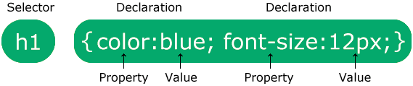

Examples :

Selector:

body {  
  background-color: lightblue;  
}  
  
h1 {  
  color: white;  
  text-align: center;  
}  
  
p {  
  font-family: verdana;  
  font-size: 20px;  
}

#para1 {  
  text-align: center;  
  color: red;  
}

Class Selector :

.center {  
  text-align: center;  
  color: red;}

**Code :**

**HTML Code :**

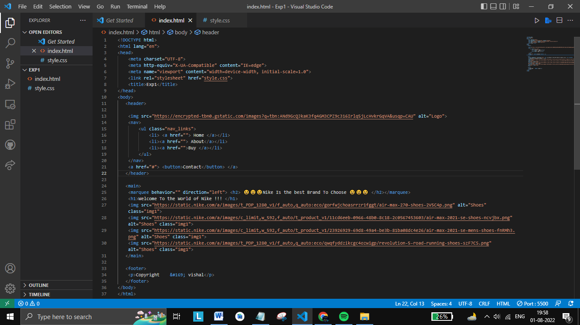

**CSS Code :**

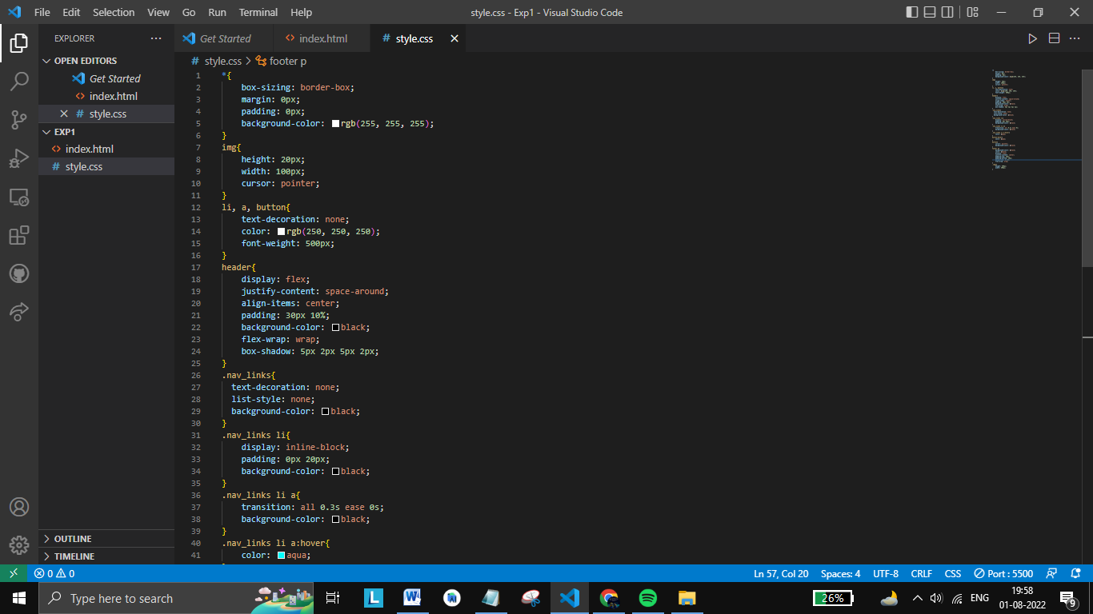

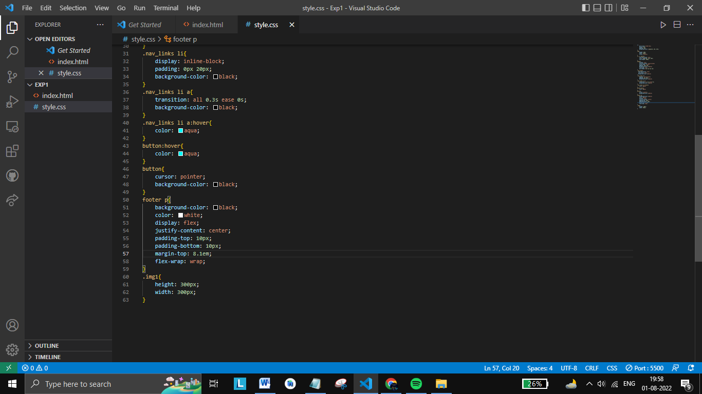

**Output :**

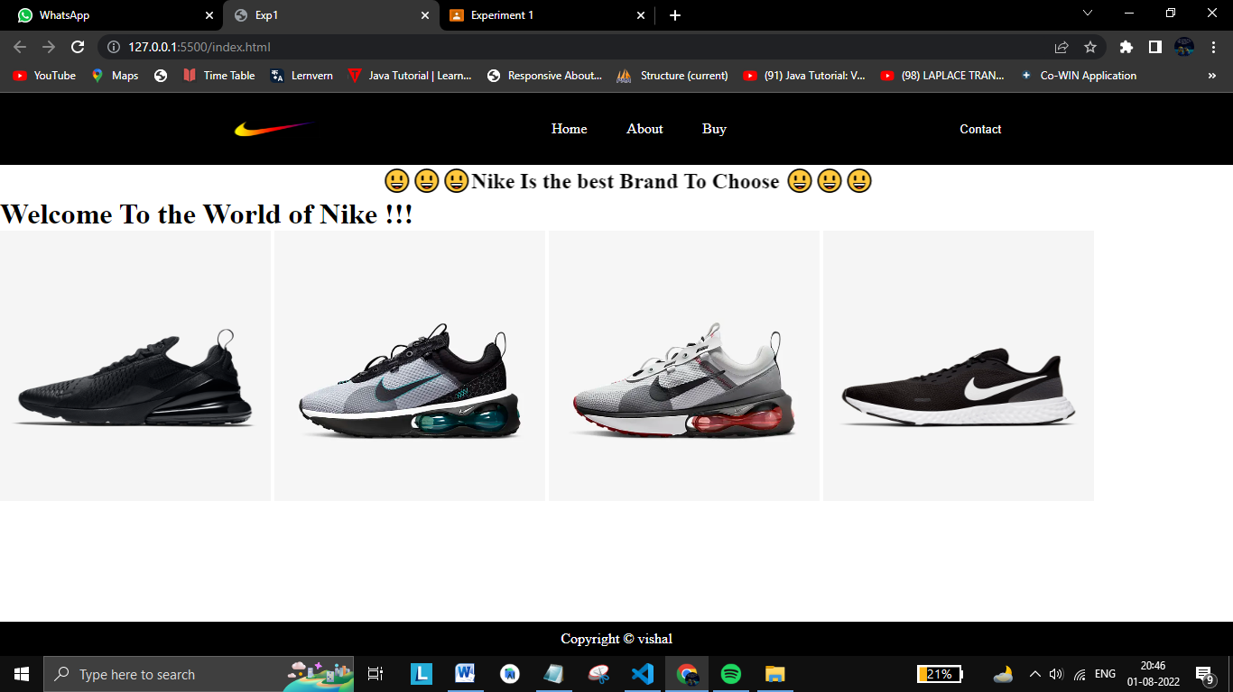

**Conclusion :** Thus, we used CSS to build our web page.